P210/6
History
(History of Africa)
1855 – 1914
Paper 6
MAY-JUNE-2023
3 hours

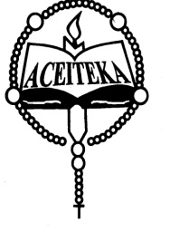
ACEITEKA JOINT MOCK EXAMINATIONS 2023
UGANDA ADVANCED CERTIFICATE OF EDUCATION
HISTORY
(HISTORY OF AFRICA 1855 – 1914)
PAPER 6
TIME: 3 HOURS

Instructions to Candidates:
Answer FOUR questions only
all questions carry equal marks
Any additional questions attempted will not be marked.

- Assess the impact of the abolition of slave trade on the people of East Africa.
(25 marks)
- To what extent was the Berlin colonial congress of 1884 – 1885 responsible for the scramble and partition of Africa? (25 marks)
- How was Emperor Menelik II able to maintain the Ethiopian sovereignty up to 1914?
(25 marks)
- Assess the impact of the discovery of minerals on the History of South Africa. (25 marks)
- Explain the factors that undermined the work of Samuel Ajayi Crowther as a missionary in West Africa. (25 marks)
- Account for the adoption and success of indirect rule in Northern Nigeria. (25 marks)
- Examine the causes and consequences of the Temne – Mende rebellion of 1898.
(25 marks)
- Assess the impact of French colonial rule over Algeria in the period 1870 – 1914.
(25 marks)
- How did the British exploit African land and labor in Kenya up to 1914? (25 marks)
- Why was Omukama Kabalega of Bunyoro able to resist the British for long? (25 marks)

END

